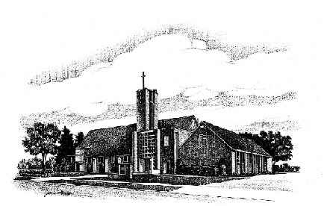
Our Savior’s

Lutheran Church

May 2020 Newsletter

“We Are An Easter People”

We continue to proclaim,” Christ is risen! He is risen, indeed!” Nothing can stop us from proclaiming this good news! Our service was recorded the week before Easter Sunday, and all churches were worshipping virtually on Easter morning. This turned out to a blessing, as we had quite a snowstorm that day. Even so, my neighbors, Rev. John and Gretchen Steer, invited some of us to gather at the corner on Easter morning at 11:00 to proclaim the Resurrection.

Jim and I donned our parkas and snow boots, as well as masks our daughter made for us, and came outside to see about 20 of our neighbors, in a giant circle at the intersection, keeping a safe distance from one another. Being together in the open air, seeing people we usually only see when passing in our cars on our way to and from work, was a joy. We waved wildly and shouted “hello!” as the snow fell around us.

John started us off, shouting the good news and we joyfully responded:

“Christ is risen!” He is risen, indeed!
“Christ is risen! Death is defeated!”
“Christ is risen! He reigns forever!”

It echoed through the trees and probably startled the turkeys, deer and birds. There is something powerful about saying it out loud, a truth that puts everything else in perspective. Nothing that threatens us is a match for the power of God to bring us through every challenge with a fierce love that will not let us go. I invite you to say it aloud right now as you read this: Christ is risen! He is risen, indeed!” Putting the words “out there” does something!

We sang “Christ the Lord is Risen Today” a cappella (not the best choir but perhaps the most enthusiastic!), reveling in each line. The final verse offering this invitation,

Soar we now where Christ has led, Alleluia!
Following our exalted head, Alleluia!
Made like him, like him we rise, Alleluia!
Ours the cross, the grave, the skies, Alleluia!

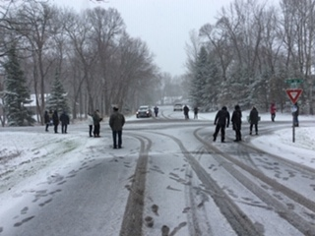

We are Easter people, as we follow Jesus in uncertain times. We’ve postponed or changed our plans, trusting in God’s plan to lead us through this pandemic with greater appreciation for our shared health and well-being; greater appreciation for those who put themselves at risk so that we might have health care, food to eat, and be safe in our homes and communities.

We follow the risen Christ, reminded of our own vulnerability, while trusting that with God’s help, we are also capable of making a dramatic difference for the good of the whole community, simply by staying home, washing our hands, wearing our masks when out, and keeping alert. We are already seeing the benefit of these changes. And while they are unsettling, often inconvenient and limit us for a time, we follow Jesus’ example in gladly doing what we can do to preserve life and offer hope.

We closed our short, impromptu Easter service by blessing each other with this blessing I offer to you now:

May the risen Christ go with you,
Before you to show you the way,
Behind you to encourage you,
Beside you to befriend you,
Above you to watch over you,
And within you to give you peace.

Amen! God bless you! I will see you soon….in God’s time.
In Christ’ love,
Pastor Susan

Reflections

with Pastor Betsy Dartt

God is teaching me so many new things these days. I am surprised by the lessons in faith. Just when I was anticipating where I was going and seeing a future filled with familiar things like gathering with the Saturday night congregation at OSL, going to a play with my friends, spending time with my children and grandchildren for Easter and birthdays, enjoying dinner out with my sisters, and welcoming spring, God gave me a lesson in faith. Everything I anticipated has changed. With the deadly threat of Covid19, there are no more gatherings at church, at the theater, or a restaurant, or even being with my family in the Twin Cities. Not only that, there was far too much snow to suit me for the middle of April; even the robins were shivering! To add to the change, my sister Gretchen and I moved into another downsized home in Rochester just before the stay in place orders. It is just right for us with our changing health needs but we are still hanging curtains, unpacking boxes (you could hear the shout for joy when we found the boxes with the favorite spatula and the missing hand crocheted bedspread made by my Grandma Betsy!). I have now become adept at zoom meetings for the worship committee, text study, and some friendship gatherings. I have found that my grandchildren are teaching me the value of FaceTime. Not only that, but we are grateful to many who have run errands or brought supplies since Gretchen’s chemo treatments make our household especially vulnerable.
St. Paul said it in 2 Corinthians 5:7, “We walk by faith and not by sight.” I am reminded that I do not see ahead what God sees. I recall that God shields me from knowing the future. I live best when I trust that the God of the universe holds all the world in mercy and love. Living in faith in these days means not worrying about the future but imagining the new things God can do with all this change. I’m learning from getting settled in our new house that we can never go back to the way it used to be. Focusing on the things that are better and new brings hope. God has promised “Fear not, for I am with you; be not dismayed, for I am your God. I will strengthen you, Yes, I will help you, I will uphold you with my righteous right hand.” Isaiah 41:10. Today I am looking forward not to what I can see but to what God can see. I trust in God’s future for us all.

Call Committee Update
The call committee is continuing to interview candidates for the position of Lead Pastor. Please keep them in your prayers as they move forward in the process of calling our next pastor

STAYING CONNECTED WHILE APART
Pastor Susan and Pastor Betsy are eager to stay connected with you during this time of social distancing! If you have a pastoral concern, or would like to talk, please call the church office or email us and we will arrange for a time to talk. We will also be reaching out in the days ahead to call each of you to stay in touch. We pray for you each day, and care about what is happening in your lives. You can reach us directly at:
Pastor Susan pastoroslsv1950@gmail.com
cell phone 507-254-9875
Pastor Betsy betsy.dartt@gmail.com
cell phone 507-884-4853
Be well. Be safe. God is with you.
Pastor Susan and Pastor Betsy

New Devotionals are available and can be mailed. Just email or leave a message on the church office phone and we will send!

Senior Choir Schedule
May 2020
Current members will be receiving an email when we know more about the church’s schedule for worship. If you would like be rejoin choir or become a new member please contact the church office for more information so that we can include you!

WELCA NEWS
Women of the Evangelical Lutheran
Church in America

All women of the ELCA are welcome to join a meeting. Please notify the hostess if you plan to attend.

We are not certain at this time when circles will be able to meet again. Members will communicate with each other as we move forward. If you wish to attend as a new member, contact the church office and we will connect you with a circle member!

Remember our Deadlines!
Articles and announcements for the newsletter: The 17th of each month. Announcements for the worship bulletin: Thursday, noon.

If you have been with us in worship and would like to be a full member of OSL, please contact either Pastor Susan Li or Pastor Betsy Dartt.

Do you have a baptism coming up in your family? Please contact the church for a baptism request form and to schedule the date. We look forward to welcoming all into our church family!

Readings for May

May 3 – 4th Sunday of Easter
1st Reading: Acts 2:42-47
Psalm 23
2nd Reading: 1 Peter 2:19-25
Gospel: John 10:1-10

May 10 – 5th Sunday of Easter
1st Reading: Acts 7:55-60
Psalm 31:1-5, 15-16
2nd Reading: 1 Peter 2:2-10
Gospel: John 14:1-14

May 17 – 6th Sunday of Easter
1st Reading: Acts 17:22-31
Psalm 66:8-20
2nd Reading: 1 Peter 3:13-22
Gospel: John 14:15-21

May 24 – 7th Sunday of Easter
1st Reading: Acts 1:6-14
Psalm 68:1-10, 32-35
2nd Reading: 1 Peter 4:12-14; 5:6-11
Gospel: John 17:1-11

May 24 – Pentecost
1st Reading: Acts 2:1-21
Psalm 104:24-34; 35b
2nd Reading: 1 Corinthians 12:3b-13
Gospel: John 20:19-23

Scriptures subject to change.

We need you, male or female! Ushers are needed to assist with handing out bulletins, helping with offering and communion, and taking care of other tasks behind the scenes before, during, and after our Sunday services. Please contact either Nevin Stender, Nancy Stender, Joan Kujath, Pastor Susan, or Pastor Betsy if you are interested in helping out.

Caring & Concerns for members & friends in Special Care Facilities:

Spring Valley Senior Living & Rehab:
Delores Erichsen, Eileen Freeman, Mary Jane Island (Ken Kraut’s mother), Maxine Jahn, Maxine Mlenar, Donna Rowe, Joan Baarsch, Dorothy Hafner.

Spring Valley Senior Living-Evergreens:
Roy & Jan Christopherson, Mick Rathbun, Elaine Sheldon, Lorraine Hancock

Spring Valley Estates:
Bev Jertson, Anita Nelson

Prairie Meadows Senior Living, Kasson:
Wil & Evelyn Mohlis

Known to be in hospice
Melvin Schmidt, Delores Erichsen

Please note!
Please remember to have family notify the church office if you are in the hospital. The privacy data laws do not allow the hospital to notify the church of your admittance.

Keep in mind that your Spring Valley Area Food Shelf is available to anyone who could use a little extra help with putting food on the table, especially with the difficult situation at this time.

The food self remains open each Wednesday from 2-4 p.m. and Saturday from 9-11 a.m.

The Backpack Food Program is giving food for families with school children at Faith United Methodist Church on Mondays and Fridays from 5pm-6pm. Also at Immanuel Lutheran Church, Wykoff on Wednesdays from 5pm-6pm.

For those who feel blessed with adequate food, remember cash or food donations to the food shelf are greatly appreciated. Thank You.

April Council Highlights

Worship Ministry Team Repairs on the organ have begun, virtual worship will be our method of safely gathering during this time, the Sister Luv service will be rescheduled, we are reviewing internet license requirements.

Youth Ministry Team Plans are moving forward for the youth retreat, the flower fundraiser will proceed if plants are available, trying to come up with ideas for summer activities.

Education Ministry Team Moving forward with plans for VBS—may need to push it back to August, Sunday School materials are being sent to the homes for children to work on.

Old Business
Talked about updating the church website, the audit is not completed, repair of the organ has begun.

New Business Packets of flower seeds with a verse will be sent to Mothers, working with Mitchell Plaehn to set up a zoom meeting for anyone interested in financial planning, there will be a zoom Confirmation meeting, the projector in the meeting room is working—thank you to Pastor Timmerman for completing this task, through email voting the council has approved moving forward to apply for the PPP forgivable loan which will be used to cover salaries and utilities, the call committee has conducted interviews via zoom, endowment request funds have been slow coming in.

Detailed minutes are available on the bulletin board by the Food Cart.
--submitted by Helen House, Secretary

We are grateful for those of you who have continued to support the ministry of Our Savior’s during this time. Your financial support, your prayers, and your caring ministries are needed at this time. We continue to count your offering on Monday mornings and Simply Giving has been a blessing during this time. You are welcome to mail your offering or to give online as you are able. We thank you for your notes of support and your prayers during this time. Know that we all miss being together!
With thanks, OSL Council and Staff

Youth News!!
Looking for a male chaperone for Retreat trip June 12-14th.

FINAL DEADLINE for Retreat Trip April 30th ! Make sure you are signed-up!!

Watch Facebook and emails for fun activities and ways to connect during this time apart.
~~~~~~~~~~~~~~~~~~~~~~~~~~~~~~~~

Education News

Sunday School
Continue to watch Facebook for live stories and Bible lessons. We miss seeing everyone face to face.

Confirmation
Our worship services are on you tube. Please continue to be involved in worship through this time. Pastor Susan sent worship notes for worship for Palm Sunday. Please send those to Pastor Susan or to Gina Jahn. 9th Grade: You MUST complete your statement of faith. We will be in contact with 9th grade families re: Confirmation Sunday.

Milestone Ministry
Please continue to work on these at home!

VBS 2020
(We are not sure if this will be able to happen in June. As soon as we know more each family will receive an email. We are praying we will all be together soon!)

VBS is fast approaching! We need YOU!, all of you to make this week a success. We need students to attend, the congregation to pray for us as we prepare, and we need volunteers to teach, donate decorating items, and individuals to help with meals!

Our theme this year is: Rocky Railway
Dates for VBS: May 31-June 4
Meal at 5:30
Opening at 6:00pm
Closing at 8:00pm

Watch for sign-ups for students! Contact an Education Ministry Team member to volunteer! It is the busiest, craziest, but most fun week of the summer all in one! Don’t miss it!

Contact Us
Our Savior’s Lutheran Church
805 S Broadway Ave
Spring Valley, MN 55975
Ph 507-346-7251

Email: oursaviorsspringvalley@gmail.com
Website: www.oursaviorsspringvalley.com
Like us on Facebook Our Savior's Lutheran
Church, Spring Valley, MN @OSLSV

Pastor Susan Li Interim Pastor
Cell: 507-254-9875
Email: pastoroslsv1950@gmail.com
Pastor Betsy Dartt-Visitation Pastor
Cell 507-884-4853 betsy.dartt@gmail.com

Staff
Audio/Visual – Darla Erickson
Bookkeeper – Kathy Merkel
Custodian – Toni Sanders
Education Coordinator – Gina Jahn Cell 251-1610
Music Coordinator/Choir Dir. – Elliott Grandall
Handbell Dir. – Myrna Legreid
Interim Office Manager – Gina Jahn
Youth Coordinator – Ann Oeltjen: oslsvyouth@gmail.com

Deaths

Dale Ristau ~ June 2, 1930 – March 27, 2020
Karilyn Reiland ~ February 27, 1941 – April 7, 2020

Memorials and Honorariums

In Memory of Don Rose
Caring Ministries Family & Friends, Dorothy Simpson, Kathy & Bob Baarsch
Organ Fund Family & Friends, Ruth & Ray Lemke, Jerry & Marlene Rollie,
Dick & Sharon Jahn
Milestone Ministries Family & Friends, Joan & Ken Kujath, Jeannette Baker
Building Maintenance Family & Friends, Kenny & Brenda Clark
General Fund Noreen Hebig, Wil & Evelyn Mohlis, Kelvin & Linda Niemeyer,
Shirley Gangstad

In Memory of Dale & Juneus Ristau
General Fund Vic & Eileen Rathbun

In Memory of Robert Jahn
Organ Fund Friends & Family, Rex & Sue Back, Jerry & Marlene Rollie, Ken &
Joan Kujath,
Cemetery Fund Friends & Family
General Fund Friends & Family, Todd & Chari Kruegel, Kelvin & Linda Niemeyer,
Marge Queensland, Ann Thon, Scott & Kelly Reiland

In Memory of Karilyn Reiland
General Fund Dick & Sharon Jahn

Due to the CoVid 19 shut down, there are no worship assistants for May and there is no May calendar of events. If we are able to continue with worship, we will send a special mailing. We look forward to being together again!

We received a joint letter from the American Legion Post #68 and the Hanson-Raabe VFW Post #4114 of Spring Valley. They have cancelled all public events for Memorial Day Monday, May 25th, 2020. They will error on the side of caution for the safety of the membership and the community. They wish to thank you for your understanding and ask that you take a time privately to recall the significance of the day.
ABC’s of WELCA Activities
A, B, C, D, E, F, G, an alphabetical list of Lutheran women’s activities

A is for action, you can each do your part
B is for Bible study, for your peace of mind
C is for conventions, and D is devotions
E is for eating, and feeling emotions
F is for family, include them when you can
G is for God, the center of our plan
H is for helping hands, I is for inclusive
J is for Jesus, his love is not exclusive
K is for kits, health, school, and sewing
L is for literacy, and leadership that is growing
M is for missions, N is for needy
O is for our offering, come on, let’s not be greedy
P is for peace and justice, and prison ministries
Q is for the quilts that we send overseas
R is for retreats, and S is for singing
T is our Thankofferings that we are all bringing
U is the unexpected things that we do
V is for video’s that we can all view
W is for workshops and worship, too
X is for the x-tra special things that we do
Y is for youth, they can be really fun
And Y is for YOU, we need everyone
Z is zebra? Because as you can see we couldn’t not think of anything that begins with the letter Z!

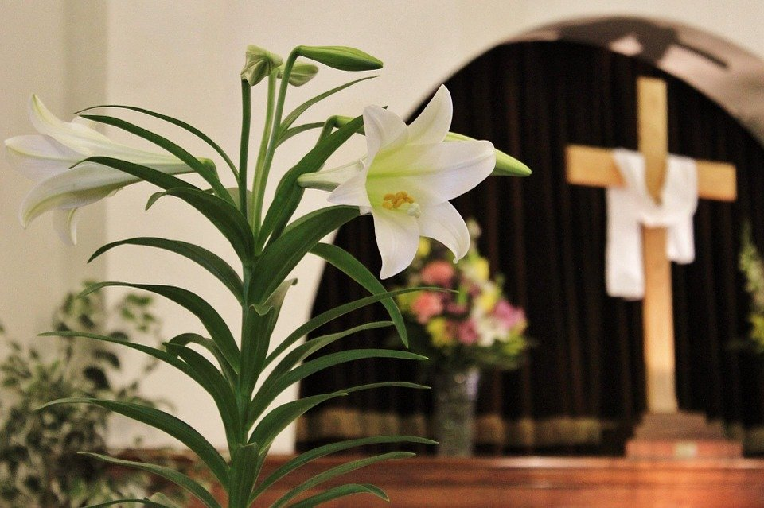
Easter Memorial Garden
Donations made to the General Fund
Given in Honor of:
Our Daughters, Shannon Nielsen, Meggon Thornburgh, Robbin Groth By Nevin & Debby Groth

Given in Memory of:
Jack Fox By: Scott, Tracy, Hannah, Rachel Meyer
Andrew Glenna, Cody Winfield
Clarence & Coleen Nash & Ora Mae Drury By: Ginny Nash & Mike Drury
Relatives & Friends By: Duane & Annette Hyland
LaVonne Keller By: Shari & Roger Davidson
Russell Hancock By: Mrs. Lorraine Hancock
Family & Bob Jahn By: Dick and Sharon Jahn
Vinton, Jennie & Pat Anderson
Art, Charlotte & Dennis Christopherson By: Roy & Jan Christopherson & family

Please recycle this newsletter when
you are finished with it.

Our Savior’s Lutheran Church NON-PROFIT, ORG
805 S Broadway Ave U.S. Postage Paid
Spring Valley, MN 55975 Spring Valley, MN
Address Service Requested Permit #71

May 2020

